**CLASSROOM ASSIGNMENT**

**Original image:**

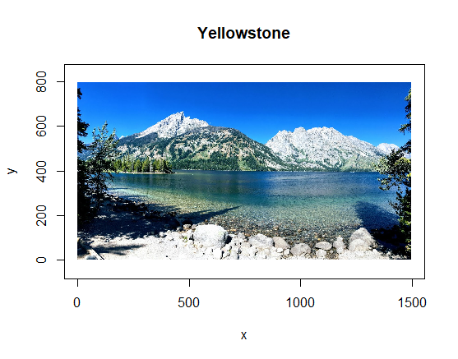

**Cluster Plots:** Plotted various plots with clusters ranging from 2 to 20. Here are a few of them.

Number of clusters: 2

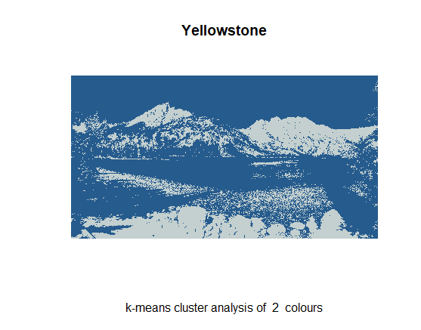

Number of clusters: 5

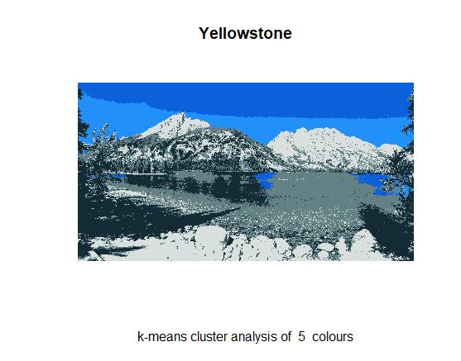

Number of clusters: 8

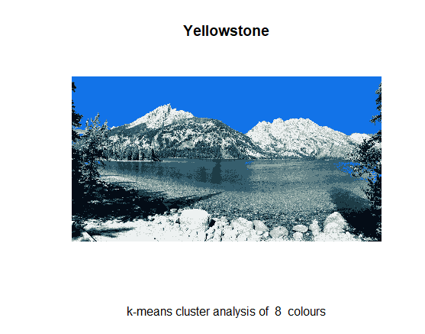

Number of clusters: 12

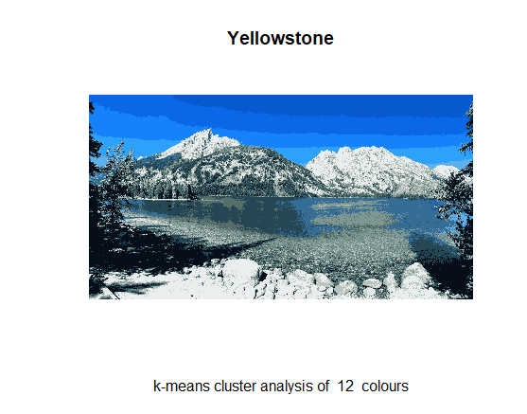

Number of clusters: 15

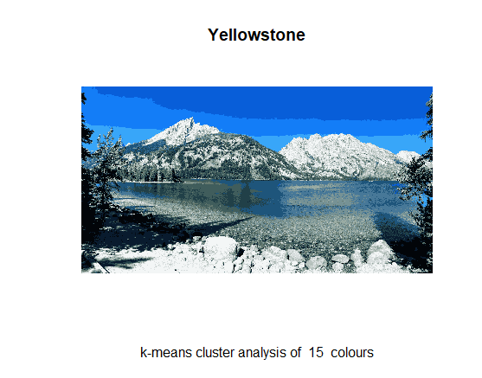

Number of clusters: 20

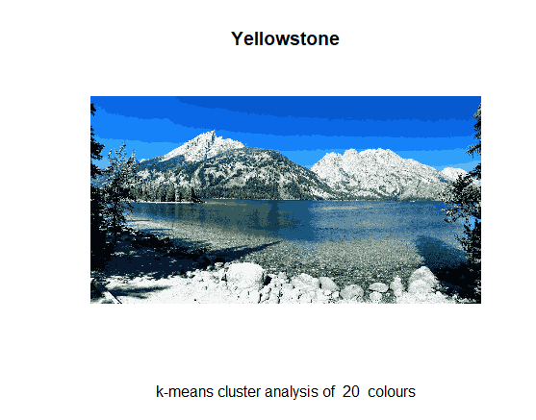

WCSS Plot with 20 clusters:

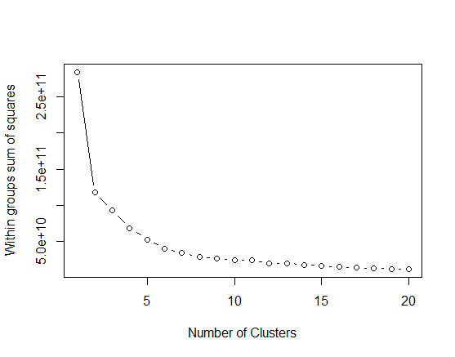

WCSS Plot with 10 clusters:

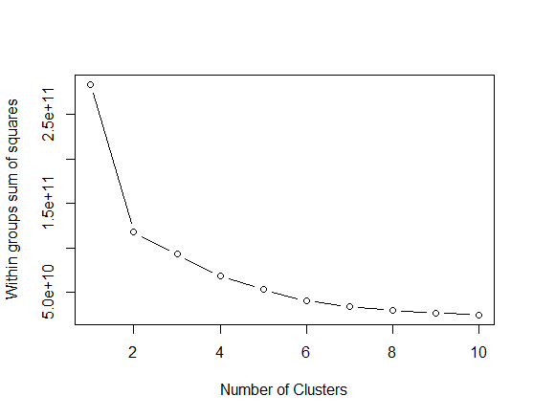

This shows that the ideal number of clusters (k value) is 6.

Images after applying PCA:

3 components:

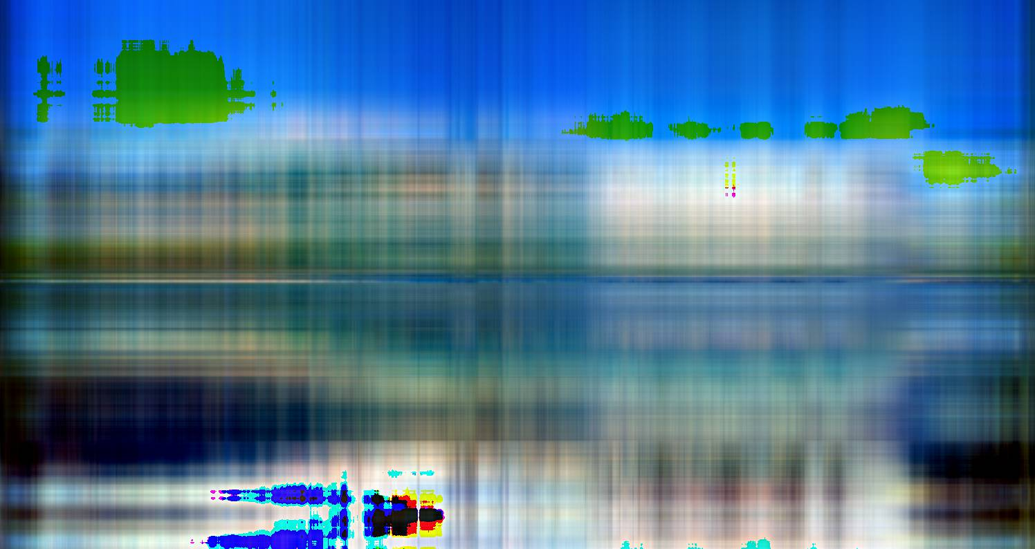

90 components:

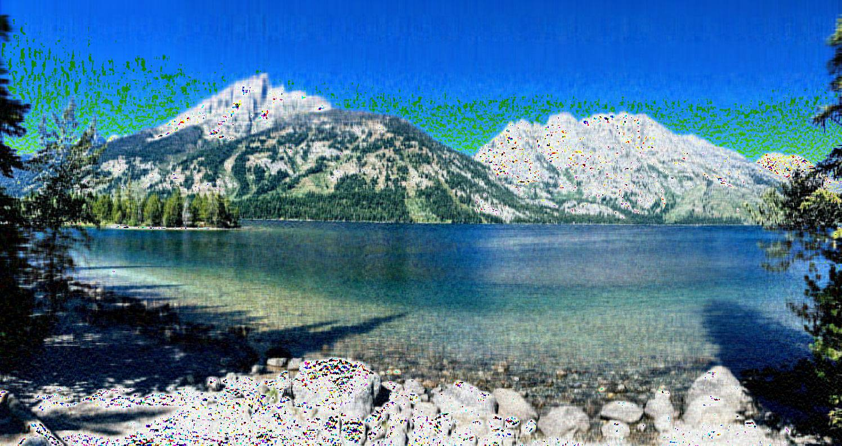

177 components:

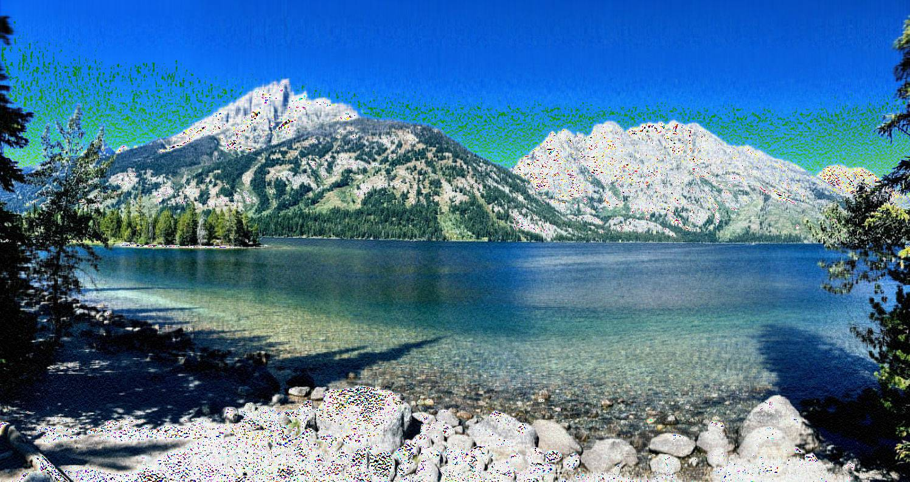

263 components:

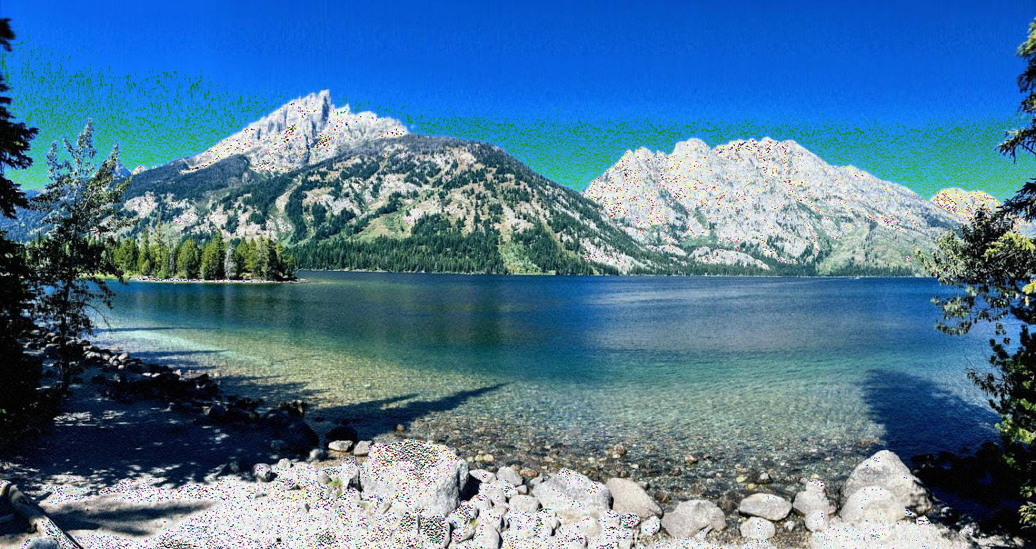

350 components:

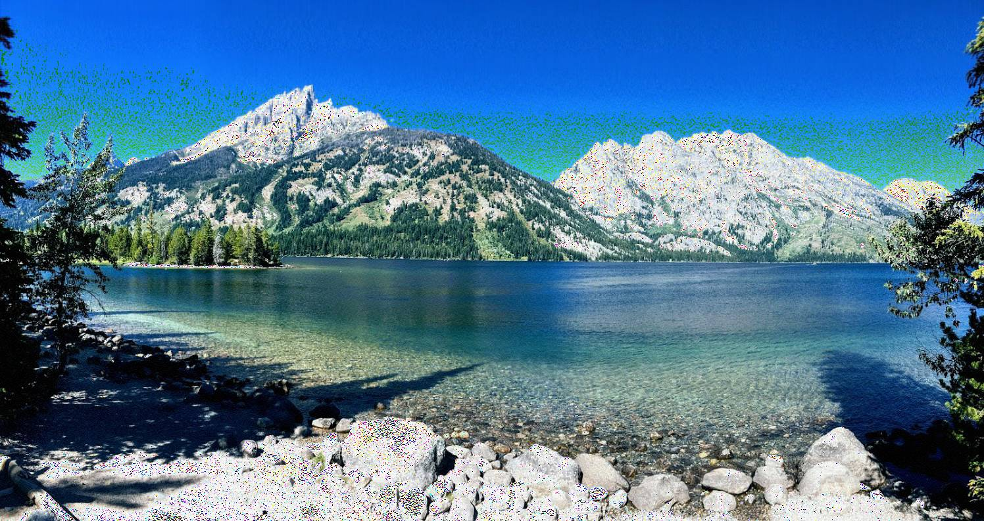

437 components:

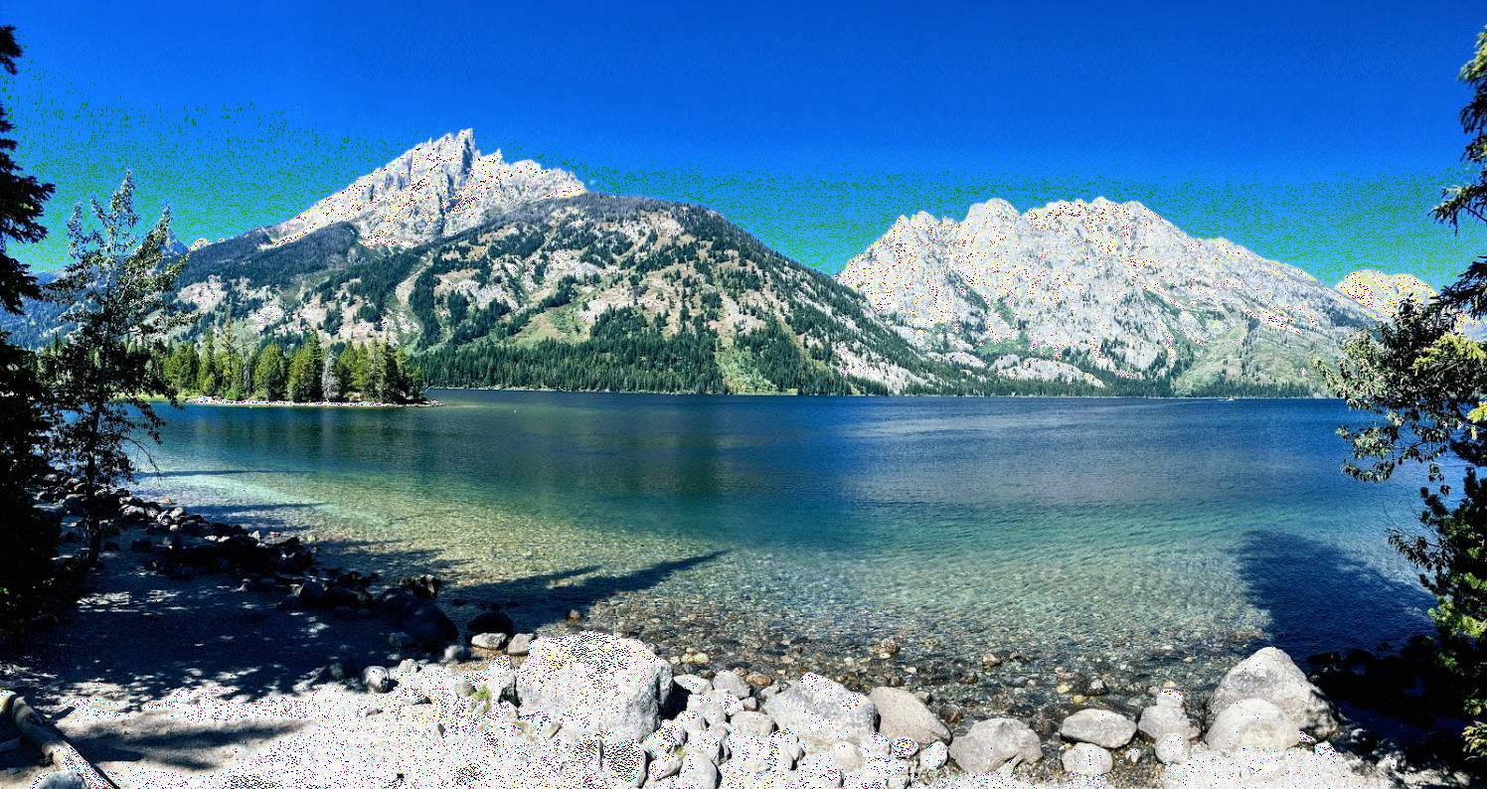

524 components:

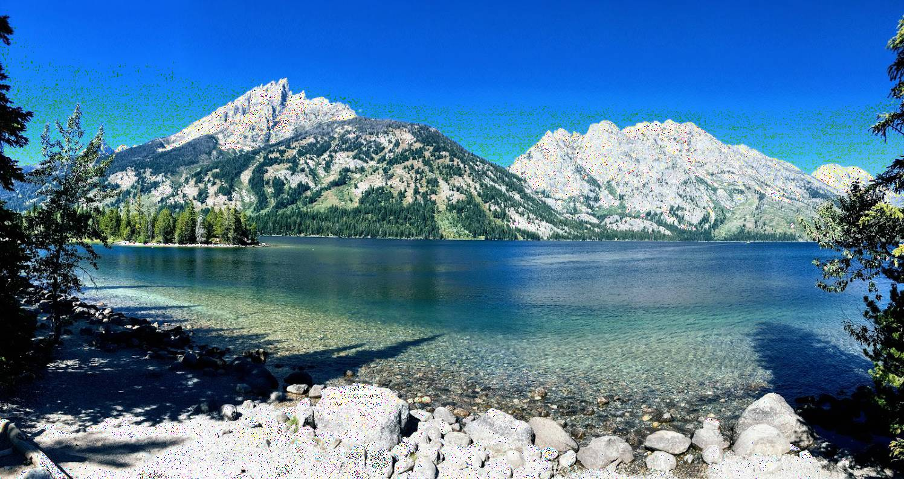

610 components:

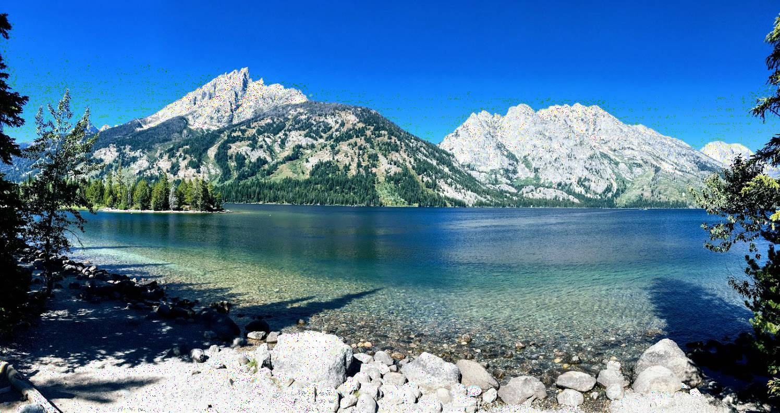

697 components:

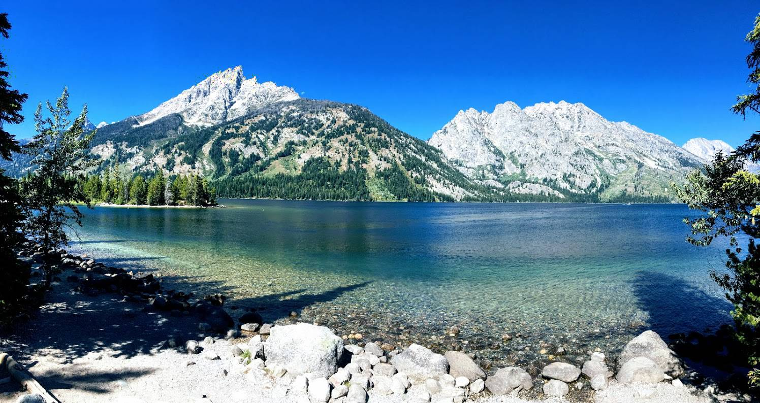

784 components:

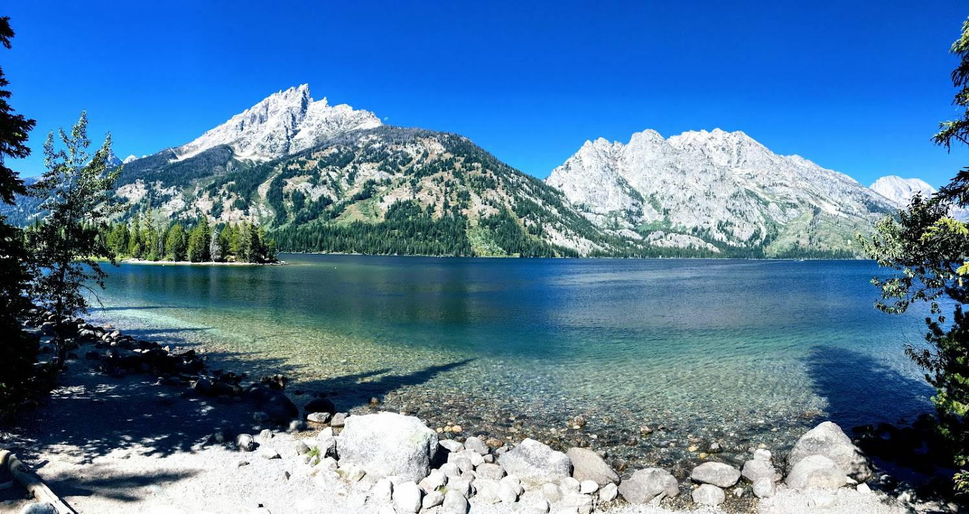

Output of PCA: compression ratio for each iteration compared to the original image

[1] "img_new_177_components.jpg size: 288.825 original: 440.066 % diff: -34%"

[1] "img_new_263_components.jpg size: 299.423 original: 440.066 % diff: -32%"

[1] "img_new_3_components.jpg size: 99.996 original: 440.066 % diff: -77%"

[1] "img_new_350_components.jpg size: 300.704 original: 440.066 % diff: -32%"

[1] "img_new_437_components.jpg size: 296.733 original: 440.066 % diff: -33%"

[1] "img_new_524_components.jpg size: 288.201 original: 440.066 % diff: -35%"

[1] "img_new_610_components.jpg size: 269.716 original: 440.066 % diff: -39%"

[1] "img_new_697_components.jpg size: 247.232 original: 440.066 % diff: -44%"

[1] "img_new_784_components.jpg size: 246.903 original: 440.066 % diff: -44%"

[1] "img_new_90_components.jpg size: 259.515 original: 440.066 % diff: -41%"

Image with 90 components is much clearer and representative of the original.

The images reconstructed from 177 to 610 components are very similar, and only slight gains in quality are made after each iteration.

The recreated image with 692 components is identical to the original. The remaining iterations will, therefore, have little improvement.